5.SYSTEM DIAGRAMS

# 5.1 DFD

## DFD for Admin

|  |
| --- |
| ACTIVITY DIAGRAM FOR ADMINISTRATOR |

## DFD for Vendor Admin

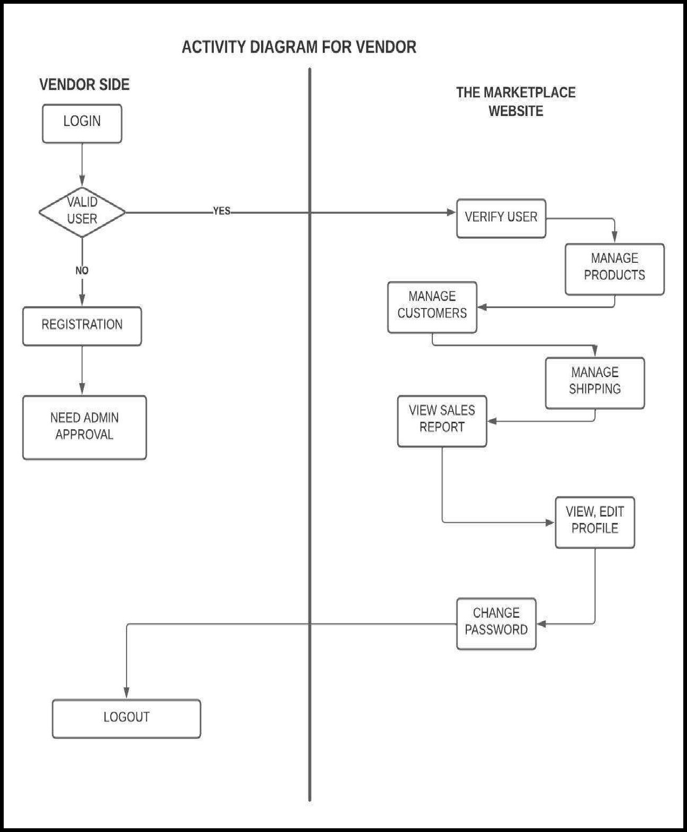

## DFD for User/Customer

|  |
| --- |
| ACTIVITY DIAGRAM FOR USER  THE  MARKETPLACE-YOUR  INVALID  No |